Hi Maria,

Thank you for the work you've done. Overall, the frames look good, except for three missing frames and a lack of subtle orange color.

Here is the link: <https://www.figma.com/file/wThuZHEfalzfw5TGVqPcan/Figma-Final-File-(Copy)?type=design&node-id=0%3A1&mode=dev&t=Fo51qRJDjeLW9m8i-1>

Here are our observations and requests for adjustments:

1. We rearranged the frames to provide a clearer view of the user workflow.
2. We added the missing "Validate Account" frame.
3. Influencer View:
   1. For the home screen, the restaurant card should display 3 interests on one line and, below it, another line stating “Available all day.” The restaurant title should be in bold, with the address not in bold.
   2. On the booking page 1, please replicate the card layout from below, add a carousel of 3 images, and include the missing favorites and share icons :

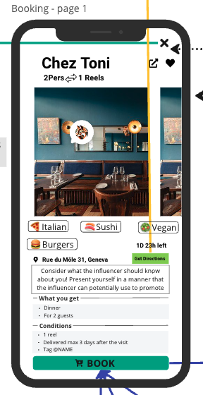

* 1. The "Accept an Offer" screen is incorrect. Please ensure it replicates the design from the provided screen :

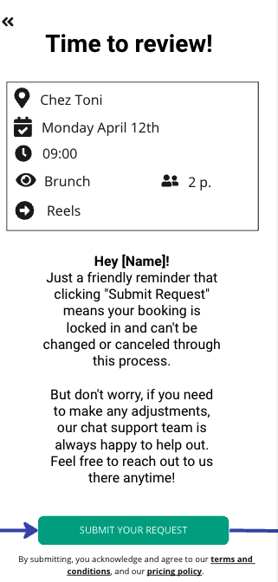

* 1. For "Favorites," the “Nothing to Show Yet” screen is missing. Instead of displaying 2x2 cards, replicate the same layout as the Experience and Booking cards.
  2. The Profile screen is missing. Please replicate the design from the provided screen :

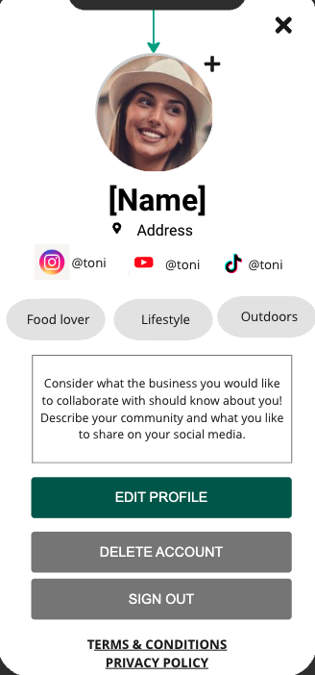

1. Business View:
   1. On the Request page, add the Instagram logo and the number of people for the offer, plus a 24-hour countdown.
   2. On the Accept Offer page, add submit terms & conditions and reduce the size of the decline button.
   3. For "Create an Offer," the inputs should be dropdown lists. Please update accordingly :

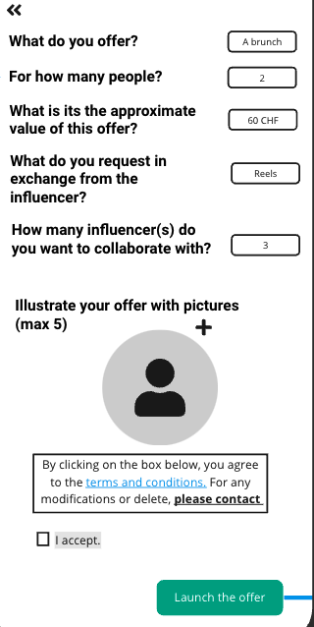

* 1. On Create an Offer page 4, you forgot to add the exchanged request (the reel).
  2. On the Congratulatory pages, the social media links of the influencer are missing.
  3. The Business Profile is incorrect (it seems mixed with the Influencer Profile). Please refer to the provided screenshot for correction :

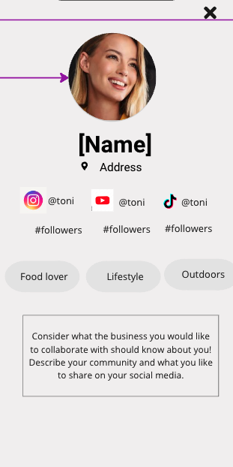

* 1. On the Payment Method screen, please add Twint and Apple Pay options :

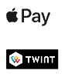

🡪 Please update the frames and incorporate the orange color used previously. Our goal is to create a sleek and inviting app that effectively engages both influencers and businesses. The app should embody the startup’s vibe and objectives.

Thank you for your attention to these details.